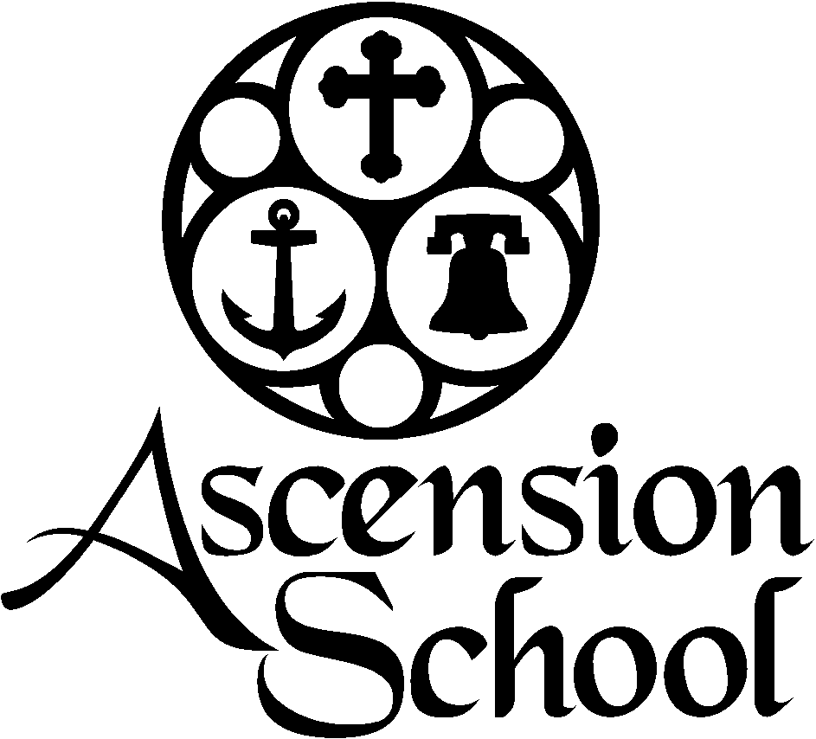

Junior Counselor Application

**Ascension School Camp & Conference Center**

1104 Church Street Cove, OR 97824 | P.O. Box 278

541-568-4514

www.coveascensionschool.com | [roman@coveascensionschool.com](mailto:roman@coveascensionschool.com)

**WHO WE ARE at ASCENSION SCHOOL**

* Year-Round Camp, Conference and Retreat Facilities.
* An Essential Ministry of the Episcopal Diocese of Eastern Oregon.
* A Place Apart for All God’s Children.
* As followers of Jesus, we are working towards the practice of unconditional love through the values of human dignity, creation care, and spiritual formation.

**GENERAL CALENDAR OUTLINE**

* July 10 – July 15: Combined Camp (Must be 14 years old)
* July 24 – July 29: Junior High Camp (Must be 15 years old)
* July 31 – August 4: Beginners Camp (Must be 16 years old)

**COVID-19 GUIDELINES**

* Staff will agree to abide by all COVID-19 Safe Camp Guidelines.
* Staff will agree to take a rapid COVID-19 test upon arrival.
* Staff will agree to regular temperature checks.
* Staff will agree to closed and open campus policies as determined by COVID-19 Guidelines.

**COUNSELOR RESPONSIBILITIES & QUALIFICATIONS**

**Shape the Camp Experience**

Our Residential Staff creates a healthy, fun, and safe experience for campers. We hire kind and firm leaders who exhibit self-awareness and emotional intelligence. The following are examples of what is looks like to shape the experience at Ascension School:

* Invest in the campers under your care and take seriously their Spiritual Formation. Help form curiosity and wonder around spiritual matters. Be inclusive and accepting.
* Welcome and include the new, scared, or anxious camper!
* Cultivate an emotionally and physically safe cabin environment. Listen to conversations and engage campers in healthy ways of relating. Respect space and encourage good roommate habits. Cultivate friendships and healthy conflict management.
* Watch for kids on the fringes and at-risk. No one stands alone.
* Have a deepened understanding of behavioral issues and mental health challenges.
* Monitor camper health, safety, behavior, and well-being.

**Set the Camp Culture**

Culture is made up of the values in a community and is often communicated in unspoken ways. Ascension School is gracious, inclusive, positive, authentic, and respectful. The list goes on! You set culture and on-board campers and volunteers to that culture. Here are some ways Junior Counselors are expected to set culture:

* Be a non-anxious and consistent presence. We are looking for emotionally healthy leaders.
* Create a positive culture.
* Be a servant-leader.
* Help campers understand the rhythms of camp by being punctual and helping them read environments and adjust themselves for the next situation. Children learn and adapt to expectations by watching role models.
* Be Christ-like.

**Examples of Day-to-Day Responsibilities**

* Be familiar with curriculum and help lead a family group.
* Help Facilitate Large Group Activities (sports, games, “Counselor Clue”, wiffle ball).
* Help Facilitate Interest Blocks (arts/crafts, sports, games) as assigned.
* Remain in cabin during sleeping hours.
* Accomplish chores with efficiency and positivity.
* Supervise free time.
* Accompany campers to the pool and field trips.
* Take breaks, get sleep, and communicate your own needs to your supervisor. Ask for help.

**Qualifications & Training**

* Passion for the Spiritual Formation of Children and Youth.
* Compatible with Ascension School culture, values, and mission.
* Experience at Ascension School Senior High Camp.
* Excellent interpersonal and communication skills.
* Must complete Ascension Application process, including references.
* Must participate in pre-session training during Senior High Camp and as a result, be familiarized with camp curriculum, schedule, activities, and general expectations.

**WORKING RELATIONSHIPS**

* Reports to Camp Director and Residential Staff as designated.
* Reports to Program and/or Executive Director as needed by Camp Director
* Works alongside volunteer Staff.
* Other relationships include Operations Manager, Kitchen & Maintenance Staff, Chaplain, and Camp Medical Staff.

**PHYSICAL REQUIREMENTS**

* Ability to reside at Ascension School for at least one camp session.
  + July 10 – July 15: Combined Camp (Must be 14 years old)
  + July 24 – July 29: Junior High Camp (Must be 15 years old)
  + July 31 – August 4: Beginners Camp (Must be 16 years old)
* Able to remain active for 12 hours per day.

**COMPENSATION**

* $175 per session
* Lifeguard Certification – additional $50