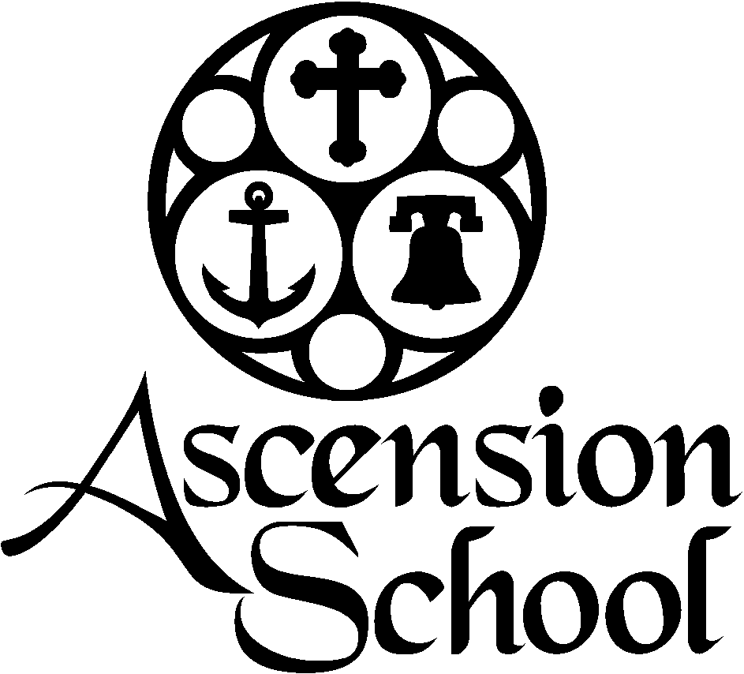

Residential Counselor Application

**Ascension School Camp & Conference Center**

1104 Church Street Cove, OR 97824 | P.O. Box 278

541-568-4514

www.coveascensionschool.com | [roman@coveascensionschool.com](mailto:roman@coveascensionschool.com)

**WHO WE ARE at ASCENSION SCHOOL**

* Year-Round Camp, Conference and Retreat Facilities.
* An Essential Ministry of the Episcopal Diocese of Eastern Oregon.
* A Place Apart for All God’s Children.
* As followers of Jesus, we are working towards the practice of unconditional love through the values of human dignity, creation care, and spiritual formation.

**GENERAL CALENDAR OUTLINE**

* June 19 – Residential Counselor Arrival by 5:00 PM
* June 20 to 25– Orientation and Training
* June 26 to June 28 – Discovery Camp
* July 3 to 9 – Senior High Camp
* July 10 to 15 – Combined Camp
* July 24 to 29 – Junior High Camp
* July 31 to August 4 – Beginners Camp
* August 5 to August 6 – Camp Cleanup and Closure
* August 7 – Residential Counselor Departure

**COVID-19 GUIDELINES**

* Staff will agree to abide by all COVID-19 Safe Camp Guidelines.
* Staff will agree to provide full COVID-19 vaccination and booster records upon application.
* Staff will receive a negative COVID-19 test prior to arrival.
* Staff will agree to rapid home COVID-19 tests upon arrival and as needed throughout the summer.
* Staff will agree to regular temperature checks.
* Staff will agree to closed and open campus policies as determined by COVID-19 Guidelines.
* Regardless of camp restrictions or cancellations, full compensation will remain. Staff will have an opt out opportunity when final decisions are made.

**COUNSELOR RESPONSIBILITIES & QUALIFICATIONS**

**Shape the Camp Experience**

Our Residential Counselors creates a healthy, fun, and safe experience for campers. We hire kind and firm leaders who exhibit self-awareness and emotional intelligence. The following are examples of what is looks like to shape the experience at Ascension School:

* Invest in the campers under your care and take seriously their Spiritual Formation. Help form curiosity and wonder around spiritual matters. Be inclusive and accepting.
* Welcome and include the new, scared, or anxious camper!
* Cultivate an emotionally and physically safe cabin environment. Listen to conversations and engage campers in healthy ways of relating. Respect space and encourage good roommate habits. Cultivate friendships and healthy conflict management.
* Watch for kids on the fringes and at-risk. No one stands alone.
* Have a deepened understanding of behavioral issues and mental health challenges.
* Monitor camper health, safety, behavior, and well-being.

**Set the Camp Culture**

Culture is made up of the values in a community and is often communicated in unspoken ways. Ascension School is gracious, inclusive, positive, authentic, and respectful. The list goes on! You set culture and on-board campers and volunteers to that culture. Here are some ways Residential Counselors are expected to set culture:

* Be a non-anxious and consistent presence. We are looking for emotionally healthy leaders.
* Create a positive culture.
* Be a servant-leader.
* Help campers understand the rhythms of camp by being punctual and helping them read environments and adjust themselves for the next situation. Children learn and adapt to expectations by watching role models.
* Be Christ-like.

**Examples of Day-to-Day Responsibilities**

* Be familiar with curriculum and lead a family group.
* Plan and Facilitate Large Group Activities (sports, games, “Counselor Clue”, wiffle ball).
* Plan and Facilitate Interest Blocks (arts/crafts, sports, games) as assigned.
* Remain in cabin during sleeping hours.
* Accomplish chores with efficiency and positivity.
* Take a turn (or two) on bus duty.
* Supervise free time.
* Accompany campers to the pool and field trips.
* Take breaks, get sleep, and communicate your own needs to your supervisor. Ask for help.

**Qualifications & Training**

* Passion for the Spiritual Formation of Children and Youth.
* Compatible with Ascension School culture, values, and mission.
* Experience working with children and/or youth.
* Excellent interpersonal and communication skills.
* Must pass a Federal Background Check and Ascension Application process, including references.
* Must participate in pre-camp training and planning sessions and as a result, be familiarized with camp curriculum, schedule, activities, and manual.
* Pass Safeguarding God’s Children Abuse Prevention courses.
* Obtain CPR/AED Certification.

**WORKING RELATIONSHIPS**

* Reports to Camp Director and Program Director as designated.
* Reports to Executive Director as needed by Program Director
* Works alongside volunteer Staff.
* Mentors Assistant Counseling and Junior Counseling Staff.
* Other relationships include Operations Manager, Kitchen & Maintenance Staff, Chaplain, and Camp Medical Staff.

**PHYSICAL REQUIREMENTS**

* Ability to reside at Ascension School from June 19 to August 7.
* At least 19 years of age.
* Able to remain active for 12 hours per day.

**COMPENSATION**

* First Year: $2000 + Room/Board
* Second Year: $2250 + Room/Board
* Third Year: $2600 + Room/Board
* Lifeguard Certification – additional $500